Chapter 2:- Installation of Linux

Install Ubuntu 14.04 Trusty
Once you've put the image you downloaded onto a DVD or USB, you will need to shut down your computer. This may be a good time to print this page, or just read through and make notes, if you're planning to install on this computer.
Once fully shutdown, Turn your computer back on, tapping the Setup key to select a boot device when your screen shows the name of the manufacturer. This key is usually a Function key (F1 to F12), or something like ESC. It will be shown on the BIOS, the screen displaying the manufacturers logo, usually along the bottom labeled Setup or Boot Settings. You can then use the arrow keys, finally hitting enter, to select either USB or Disc Drive.

1. Click Install
Once Ubuntu has booted, you will be presented with a screen that looks like this.
Click Install Ubuntu to install. You can open the installer again later if you choose to try it out, but remember it will be far slower running from a Disc/USB than had you installed it, and nothing you do will actually be saved.

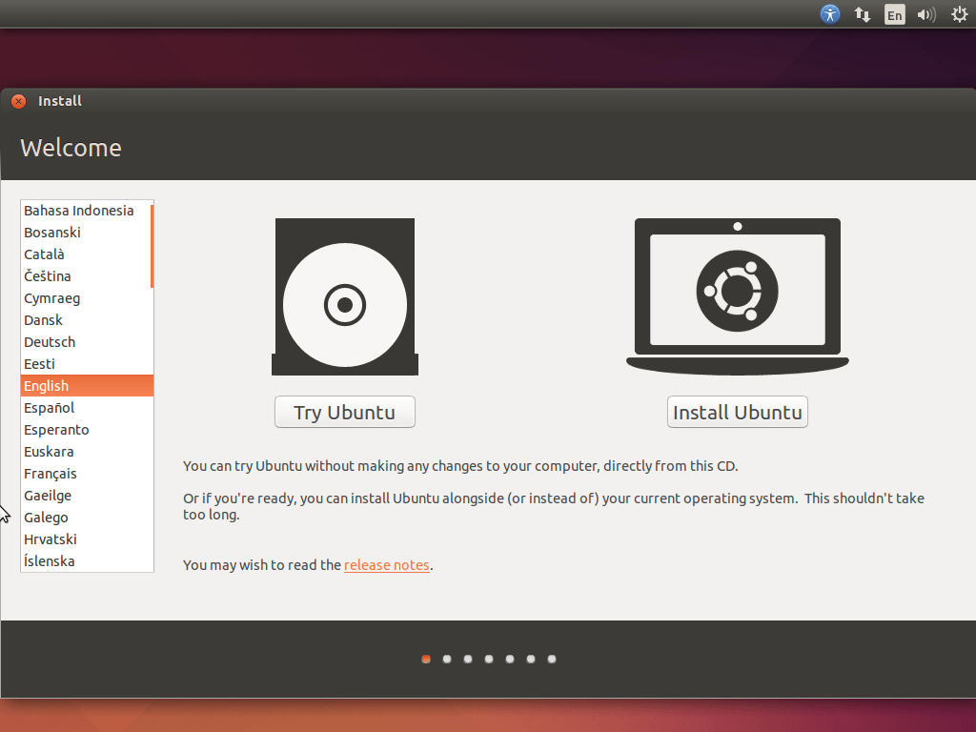

2. Check both Boxes
We recommend checking both boxes, but if you don't want to install all updates while installing, or don't want to play MP3 files (music), then you can leave the relevant box(es) unchecked.
If you don't have at least 4.5GB of available drive space, then you can't continue. If you're not plugged in, then plug in before continuing. If you're not connected to the internet, then you'll be prompted to connect when you click continue. You can do it now using the icon to the left of the sound menu to connect. Mine shows two arrows, as I'm plugged in, disconnected it looks different, and a little change again if using WiFi. You can continue without connecting, but you won't be able to get updates, or any language packs you may require.

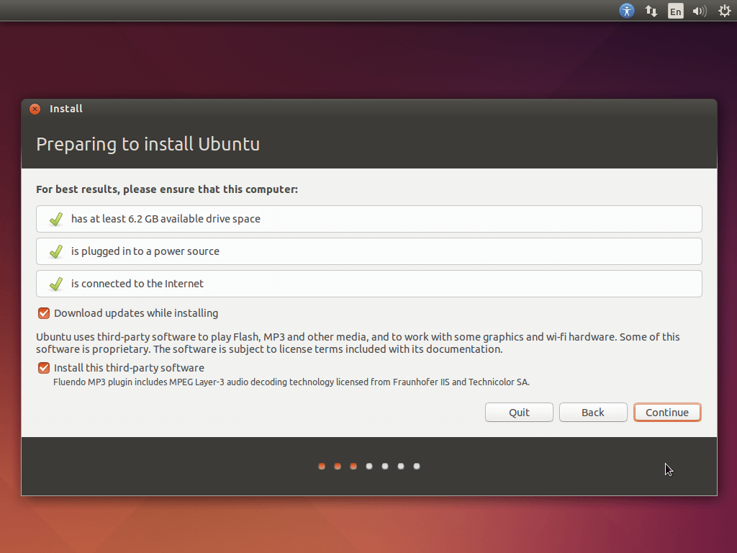

3. Choose How to Install
Yours will probably look a little different to mine here. My hard drive doesn't have anything on it yet, so i can choose either to use the whole disk, or specify partitions manually (surprisingly easy stuff). Yours may have a slightly different first option, and one or two extra.
It may say Delete Windows and Install Ubuntu and Shrink Windows and Install Ubuntu Alongside.
Choosing to install alongside will mean you are presented with a menu with the option to choose which operating system with the arrow keys and enter every time you turn on your computer.

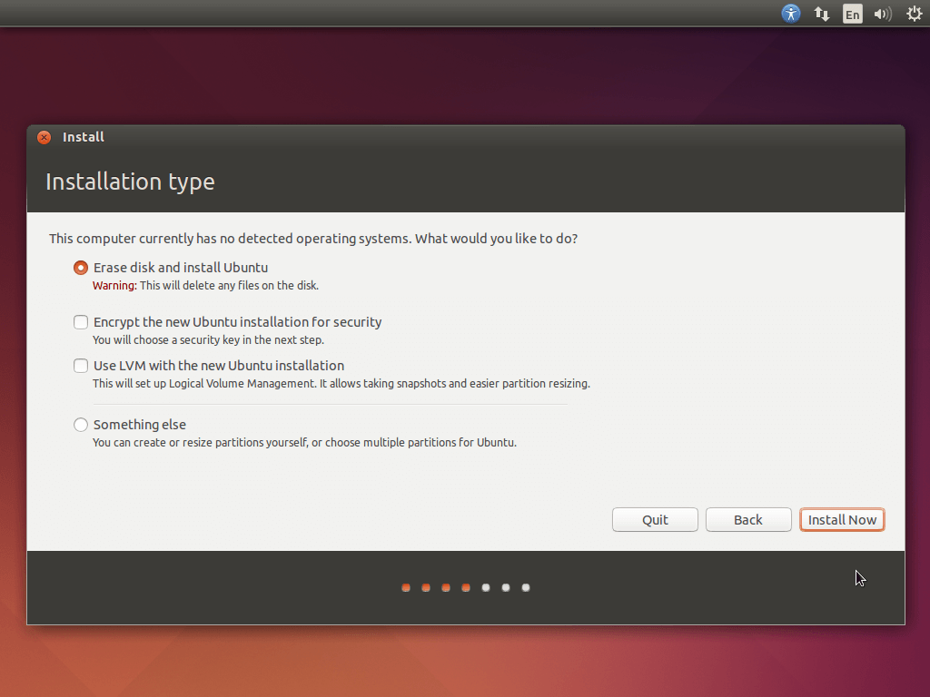

Warning
In this step you could potentially erase your entire computer. This means all your programs, documents, photos, videos, and everything else could be lost. Be careful, especially if you plan to remove Windows or OS X and use only Ubuntu, or if you are installing to a USB Drive.

Make sure you understand where it is being installed and how it will effect your data. This is the last point at which you can safely cancel the install without potential data loss.
It is always a good idea to make backups.
If you have not done so already, backup your data.

4. Confirm your Choice
After clicking continue, you may be presented with a confirmation screen, much like this, to confirm your choices.
Click Install Now to begin installing.
You'll be asked a few more questions in a second about where you are, what your name is, and how you want your computer set up. These are for time settings, user names, and home folders.

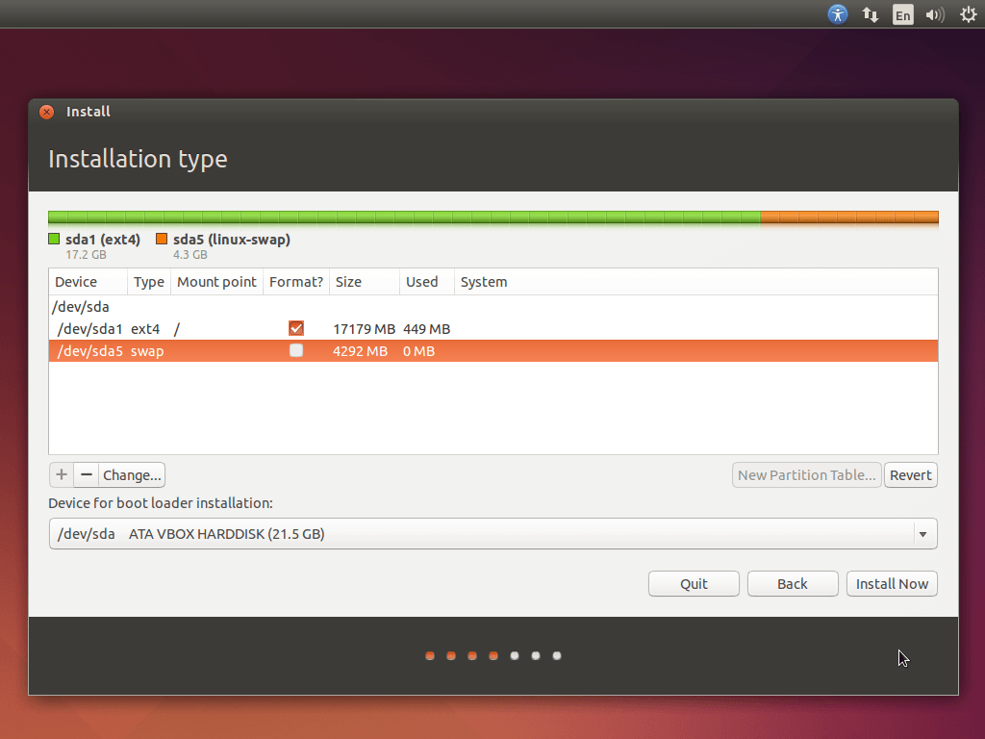

5. Choose your Location
Now you get to choose your location by dropping a pin on this nifty looking map. This is to select your timezone and apply any regional adjustments.

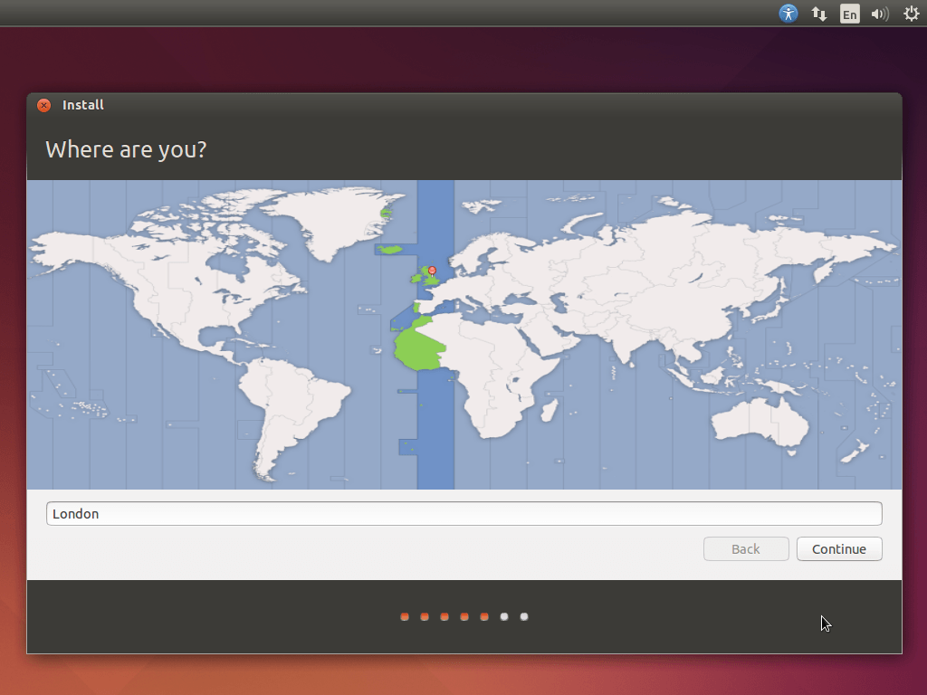

6. Choose your Keyboard Layout
This is probably the most technical step in the installation, made a lot simpler by the Detect Keyboard Layout. Just click that and follow the instructions on screen.

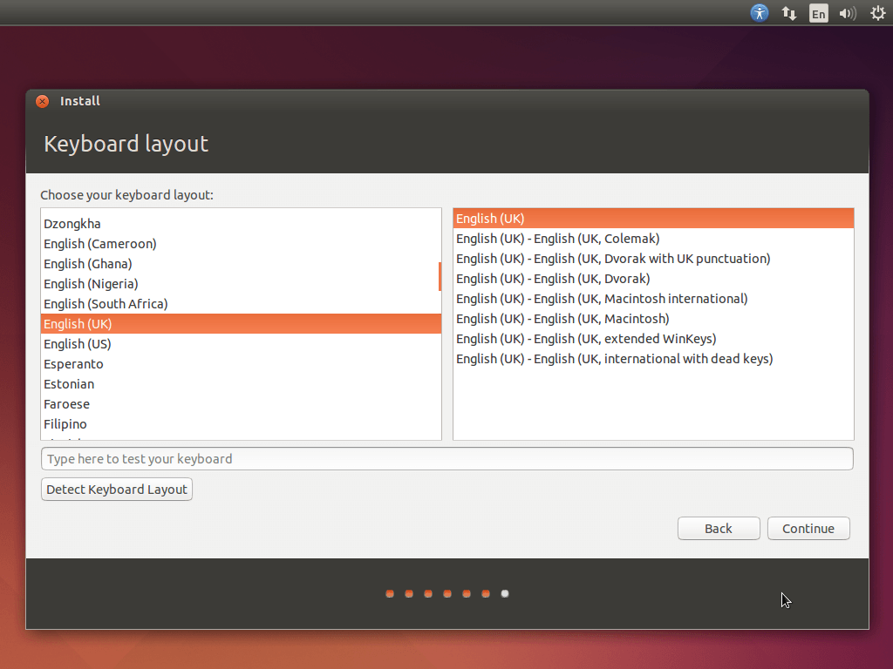

7. Set a Username and Password
Now you get to enter your name, the name you want your computer to be (not really important), your username (again, you won't see this much, but it can't have capitals or spaces, best leave as it is made from your real name), a password (if you want, then confirm it, and keep it strong), whether or not to log in automatically, and whether or not to encrypt your home folder (which is where documents, music, and video folder can be found, among others).
I would not recommend encrypting your home folder, as this usually complicates things for you as much as any potential trespassers. It can lead to complications with keyrings, forgotten passwords, and bad data recovery. Only use if it is a company policy, or you thoroughly understand what you are doing. Also, only set your password to nothing if you are unlikely to ever want one, otherwise yet more compilations with keyrings and automatic unlocking-on-login can arise.

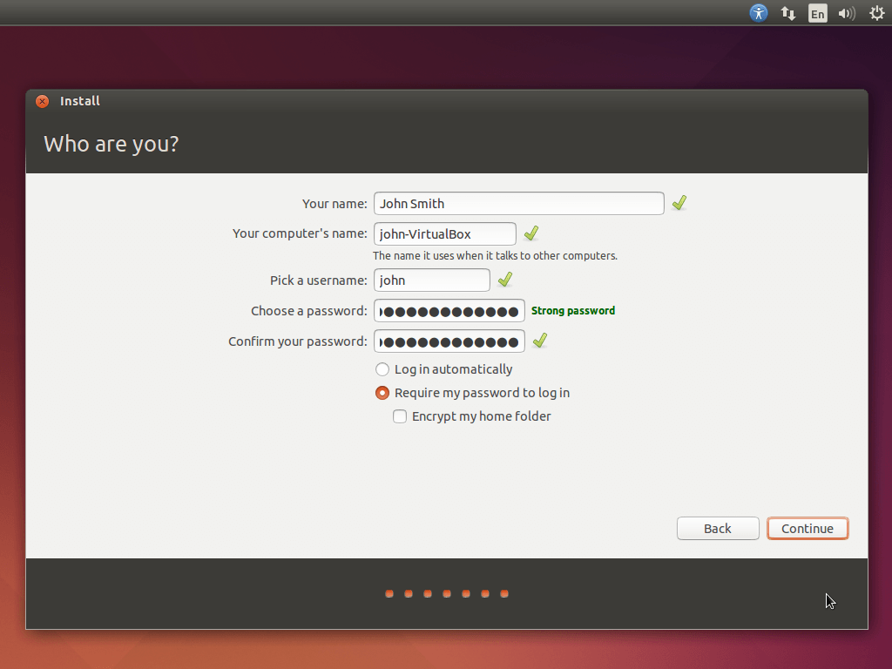

8. Sit Back and Relax
Sit back and enjoy a little slideshow about Ubuntu, all the free, full-version software you've got, and just how great it is to have installed Ubuntu 14.04 Trusty Tahr LTS.
You can rest easy in the knowledge that your computer is faster, safer, and simpler to use, now it's running a free open-source system.
Check out askubuntu.com if you need any further help.

